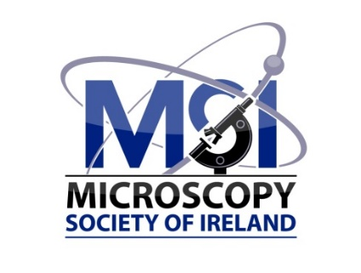

**Microscopy Society of Ireland**

**European Microscopy Congress (EMC) 2024 Travel Award**

For members of the MSI, we are offering an opportunity to apply for a travel award to attend [EMC2024](https://emc2024.eu/) in Copenhagen, 25 - 30 August 2024.

**1. ELIGIBILITY & REQUIREMENTS**

Criteria for the award of a EMC2024 Travel Award include the following:

* Applicants must be members of MSI for at least six months prior to submitting their application for this award.
* This award is open to:
  + postgraduate students
  + postdocs
  + technicians and imaging scientists within 8 years of starting work or studies in a microscopy-related field (excluding career gaps).
* Applicants must intend to present their research at EMC2024 and must have submitted an abstract for presentation, either as an oral or poster presentation. This abstract must also be submitted to the committee at the time of application. This award is subject to the abstract being accepted.
* The research presented at the EMC2024 must include some element of microscopic investigation or analysis.
* A covering letter explaining the reasons for attending EMC2024 should be submitted, in addition to a breakdown of costs involved. Student members should also submit a signed letter of support and evidence of their student status from their supervisor.
* The award amount will be up to €500. The actual amount awarded may be less than €500 if the number of applications received are higher than anticipated. This award will be in the form of expense reimbursement following attendance at the conference.
* After the conference, awards winners will be required to prepare a short report for publication on the MSI website.
* Applications received will be reviewed by the MSI Committee.
* The deadline for applications is the **30th of April 2024.**

**2. APPLICATION FORM**

***Please note: All applicants must be a registered member of the Microscopy Society of Ireland.***

|  |  |
| --- | --- |
| **Name:** |  |
| **Email:** |  |
| **Course (if applicable):** |  |
| **Departmental**  **Address:** |  |
| **Supervisor/Line Manager:** |  |
| **Supervisor’s/Line**  **Manager’s contact**  **details:** |  |

**Justification for EMC 2024 travel award to a maximum of €500.**

|  |
| --- |
|  |

**All applications should be sent to: The MSI Secretary, Microscopy Society of Ireland at** [**secretary@microscopy.ie**](mailto:secretary@microscopy.ie)

***Applicant’s signature:___________________________________________ Date:____________***

*For student applications, a signed letter detailing reasons for attending the conference is also required from applicant’s supervisor or Head of Department. The letter should also include a declaration that the Award will be returned to MSI should, for any reason, the applicant cannot attend the conference and/or prepare a report for publication on the MSI website.

*It is a condition of the Conference Travel Award scheme, that successful applicants present their work to the Society in the form of a report to be published on the MSI website.*

**3. SELECTION**

Applications received will be reviewed by the MSI Committee.

**4. REGULATION**

The Secretary will verify whether each applicant is a member of the MSI.

**5. NOTIFICATION**

The successful applicants will be notified at least 6 weeks prior to the start of the conference. Applicants must inform the Committee if they receive other funding to enable them to attend EMC2024 without MSI support.

**6. AWARD**

The MSI undertakes to pay, funds permitting, for each successful Awardee an award of up to €500. The actual amount awarded may be less than €500 if the number of applications received are higher than anticipated. This award will be in the form of expense reimbursement following attendance at the conference.